Give the equation, use drop down for the rest

Equation: $f(x)= 2|x+1|-2$ | Domain: $(-∞, ∞)$
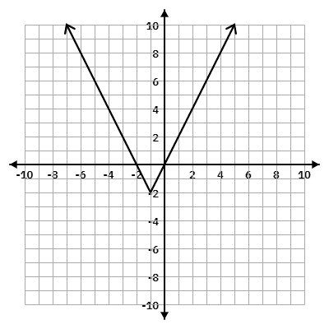 | Range: $[-2, ∞)$
X-int: (-2, 0) and (0, 0)

Y-int: (0, 0)

 | Axis of symmetry: x = -1
 | Vertex: (-1, -2)
 | Max/Min: Min at (-1, -2)
Verbal Description: Vertical Stretch by factor of 2, Left 1, Down 2

Function Notation Description: $2f(x+1)-2$

Give the graph, use drop down for the rest

Equation: $f(x)=-\frac{1}{3}\left|x-2\right|-4$ | Domain: $(-∞, ∞)$
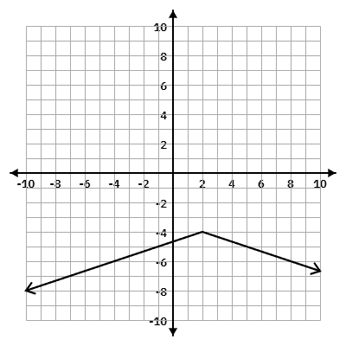 | Range: $(-∞, -4]$
X-int: None

Y-int: (0, -4.5)

 | Axis of symmetry: x = 2
 | Vertex: (2, -4)
 | Max/Min: Max at (2, -4)
Verbal Description: Reflect over x-axis, Vertical Compression by a factor of ⅓, Right 2, Down 4

Function Notation Description: $-\frac{1}{3}f(x-2)-4$

